
Name: NHS No:
Telephone: Surgery:

Day/  date | Pre  Breakfast  Glucose level  Insulin Dose | Breakfast  Foods Eaten | Pre  Lunch  Glucose level  Insulin Dose | Lunch Food  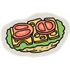  Eaten | Pre  Evening  Meal  Glucose Level  Insulin Dose | Evening Meal  Eaten  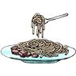 | 2 hours after main meal  Glucose level  Insulin Dose | Bed  Time  Glucose | Special  Comments/  Exercise  Today  